# HOL 7 : Deploying AKS cluster on azure.

**Objective:**

**Learn AKS cluster creation on azure using Azure Cloud Shell. This LAB will prepare a multi-host cluster using AKS and deploy a sample application.**

**Duration: 30 Minutes**

**Prerequisites:**

1. Azure Subscription
2. Internet Connection
3. SSH Client (Ubuntu Bash or Git Bash)
4. Web Browser (Any)
5. Text editor (Visual Studio code recommended)

**Steps:**

1. Create a new cloud shell in portal.
2. Login in Azure portal, on right-top corner, find an option for cloud shell.

It should open a panel which let you choose cloud shell (Bash or Powershell)

Select “Bash (Linux)”

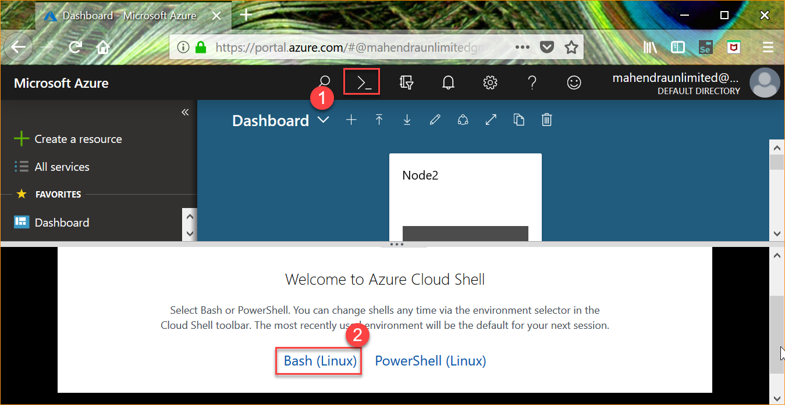

1. Click “Create Storage Account” button

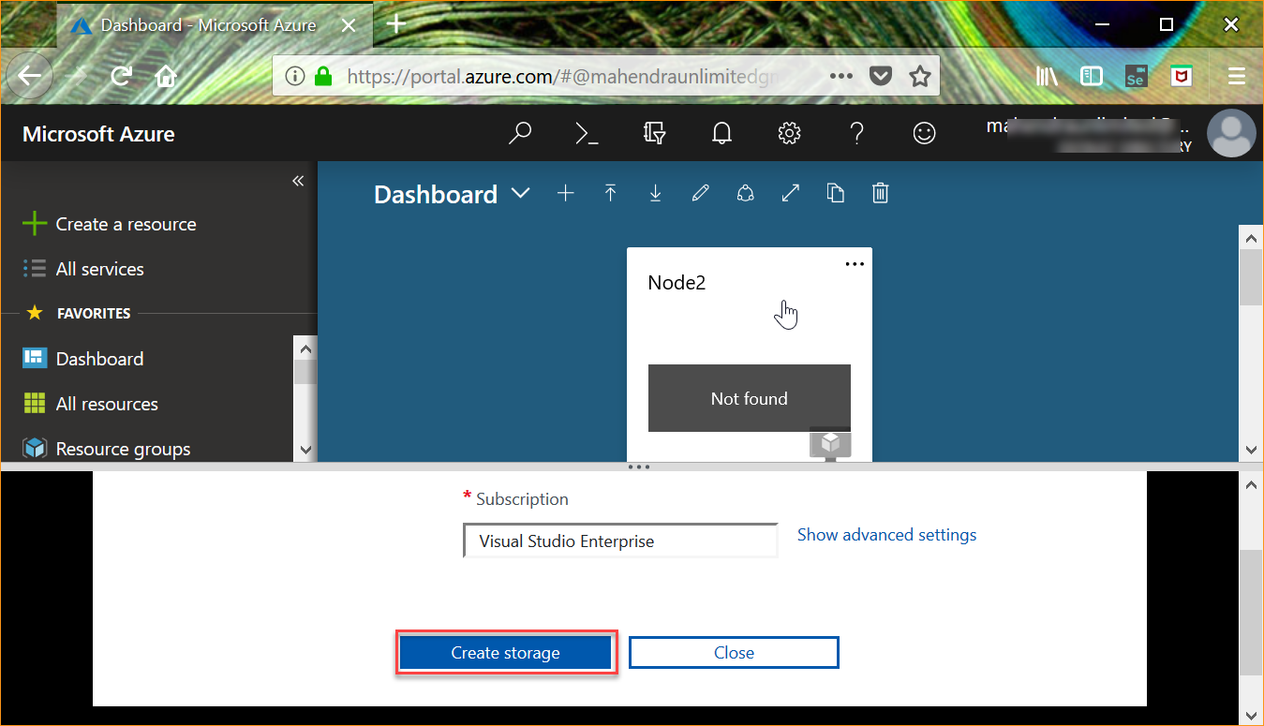

1. Once ready, cloud shell should print Linux bash like promp

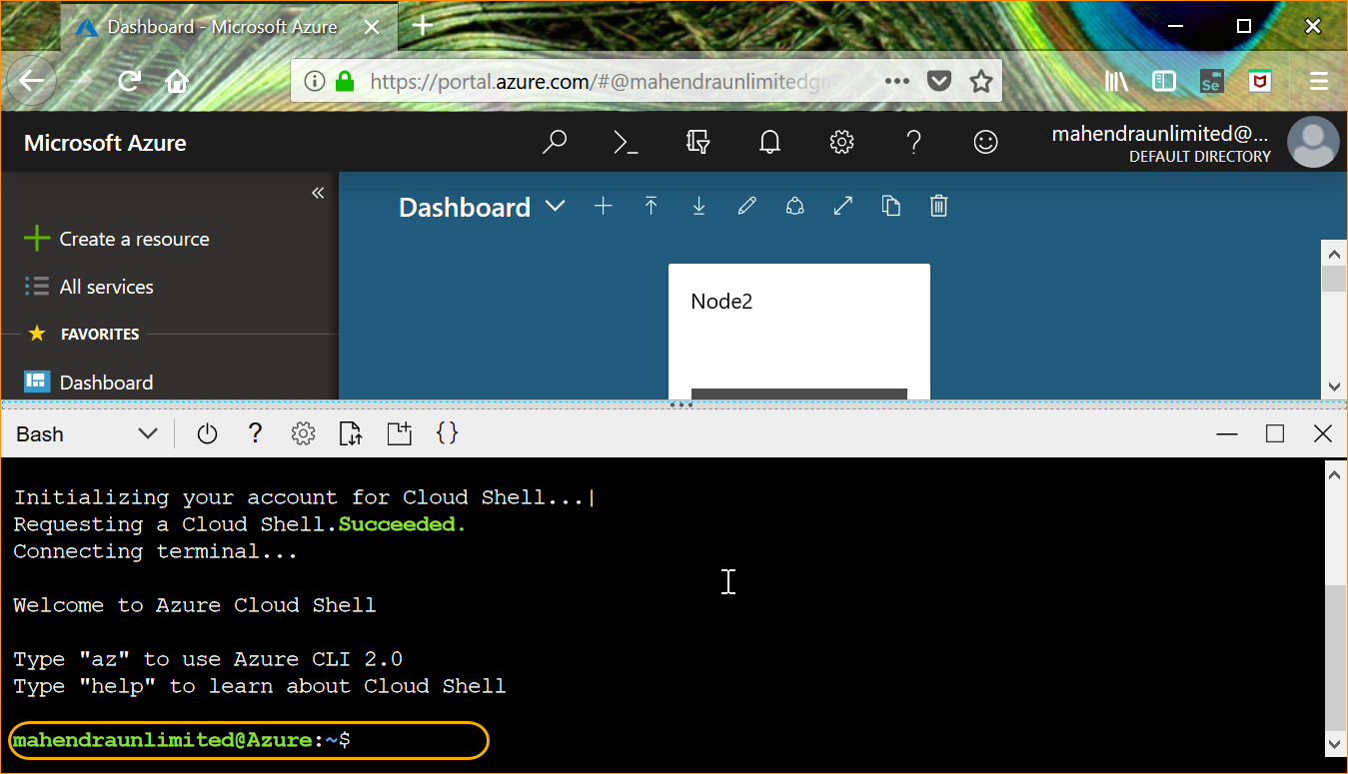

1. Create AKS cluster
2. Create a new resource group

$ az group create -n test-grp1 -l southeastasia

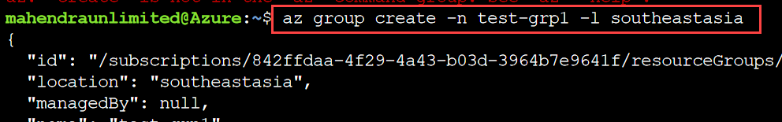

1. Now, try following command to create a cluster

$ az aks create --resource-group test-grp1 --name aks-01 --node-count 1 --enable-addons monitoring --generate-ssh-keys



Wait for the deployment to finish. (May take more than 20 minutes)

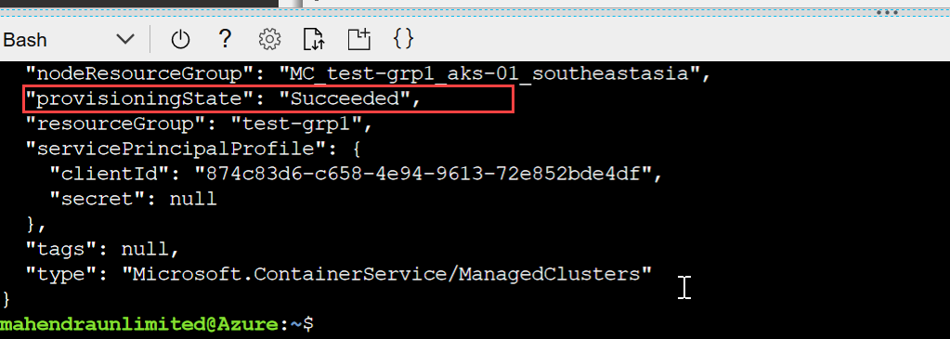

1. Get AKS credentials

$ az aks get-credentials --resource-group test-grp1 --name aks-01

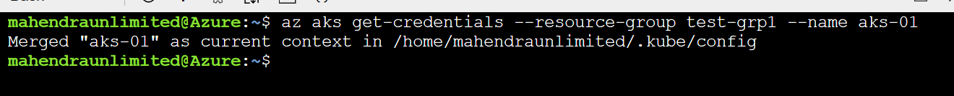

1. Now lets test the kubectl command

$ kubectl get nodes

1. Now, download new sample deployment file

$ wget <https://raw.githubusercontent.com/mahendra-shinde/docker-demos/master/azure-vote-app/azure-vote.yml>

1. Try deploying new application

$ kubectl apply -f azure-vote.yml

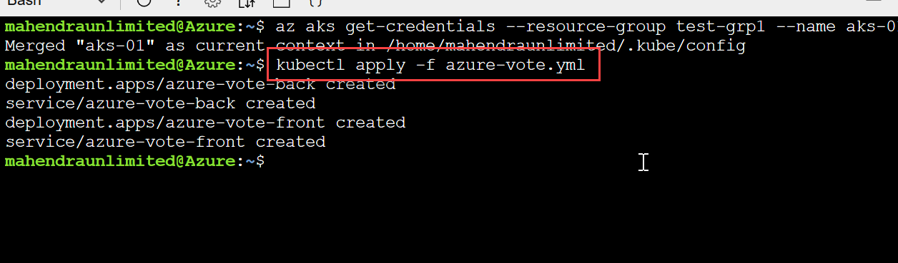

1. Try getting external IP assigned to service using following command

$ kubectl get service azure-vote-front –watch

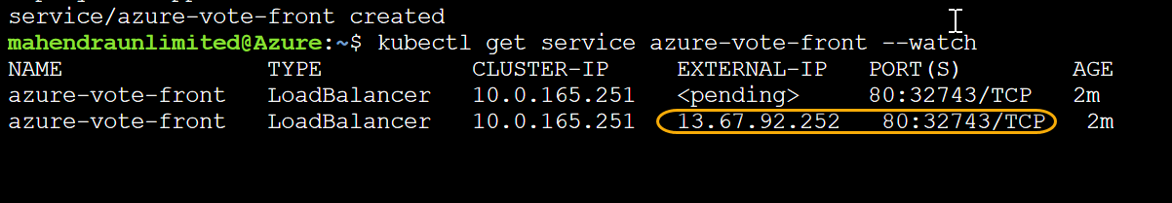

1. Use this IP address as URL to access sample app from browser

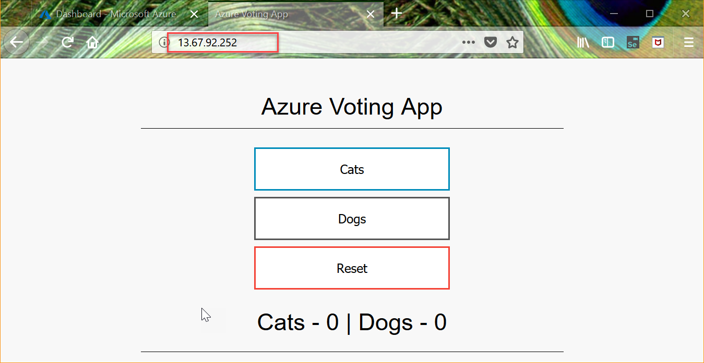

1. Clean Up

Delete resource group test-grp1 and additional one contain “aks-01”